# Upgrade IT Professional 2020 (M365/Office365) to NITRO Help Desk 2023

**Applies to**: IT Professional 2020 (SharePoint Online)

## Introduction

Crow Canyon recently released NITRO Help Desk 2023, a newer version of its IT Help Desk application. New features released as part of NITRO Help Desk 2023 are:

1. Revamped Application Administration Page
2. [Service Level Agreements](https://www.crowcanyon.com/wp-content/uploads/2023/06/SLA-1.pdf)
3. [Surveys](https://www.crowcanyon.com/wp-content/uploads/2023/06/Survey-1.pdf)
4. [Needs Attention](https://www.crowcanyon.com/wp-content/uploads/2023/06/Needs-Attention.pdf)
5. [’Merge Tickets’ Custom action in ‘Tickets’](https://www.crowcanyon.com/wp-content/uploads/2023/06/Merge-Tickets.pdf)
6. [‘Link to Problem’ custom action in ‘Tickets’](https://www.crowcanyon.com/wp-content/uploads/2023/06/Link-Tickets-to-Problem-1.pdf)
7. [‘Link Tickets to Problem’ custom action in ‘Problems’](https://www.crowcanyon.com/wp-content/uploads/2023/06/Link-Tickets-to-Problem-1.pdf)

If you are interested in using these features, please follow this document. If you are stuck at any place or need help, please contact [crowcanyonsupport@crowcanyon.com](mailto:crowcanyonsupport@crowcanyon.com) for support.

### Pre-requisites

1. User doing the upgrade should be a site collection administrator.
2. User should know the portal site URL as it will be needed during the upgrade.
3. Ensure at-least “Contribute without delete” permission level is configured in the site collection.

### Run “IT Helpdesk Upgrade” application.

To run the “IT Helpdesk Upgrade” application, go to the root site collection 🡪 Site Contents 🡪 Open Crow Canyon NITRO Studio 🡪 NITRO Applications 🡪 Search for “IT Helpdesk Upgrade application” 🡪 Click “Install” to run the upgrade application.

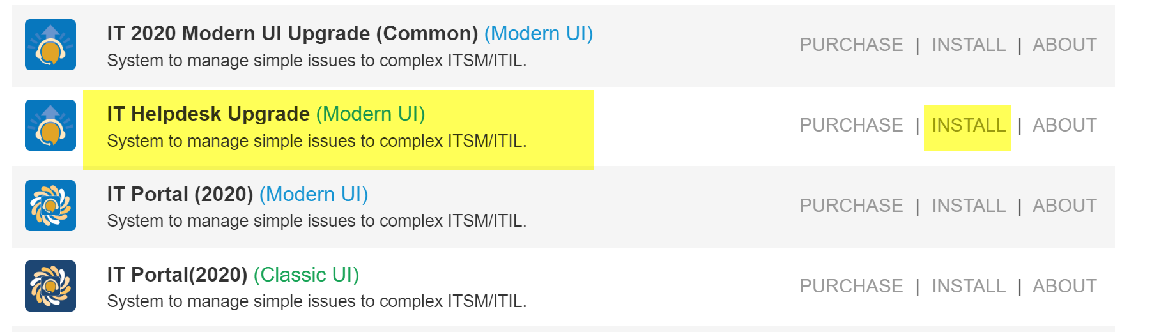

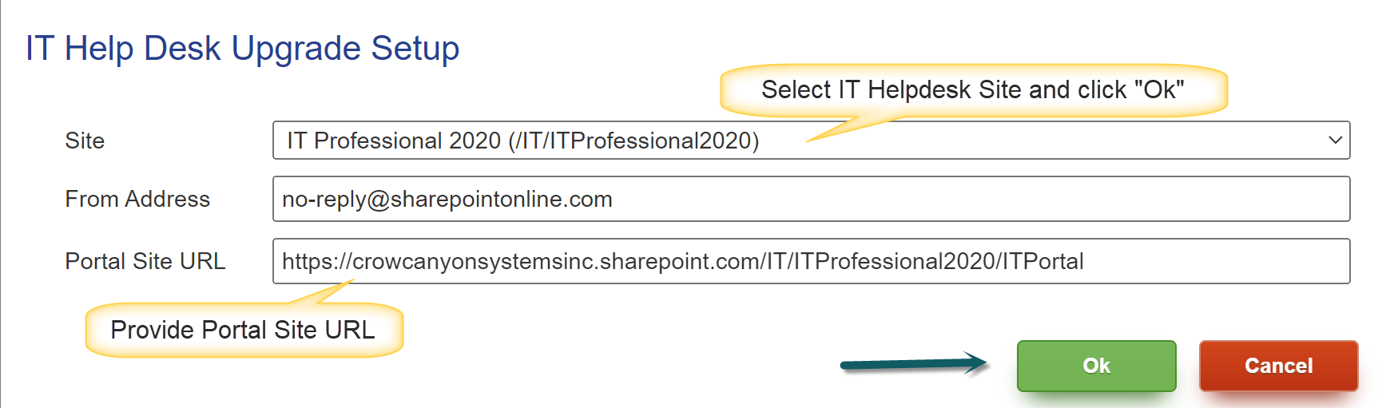

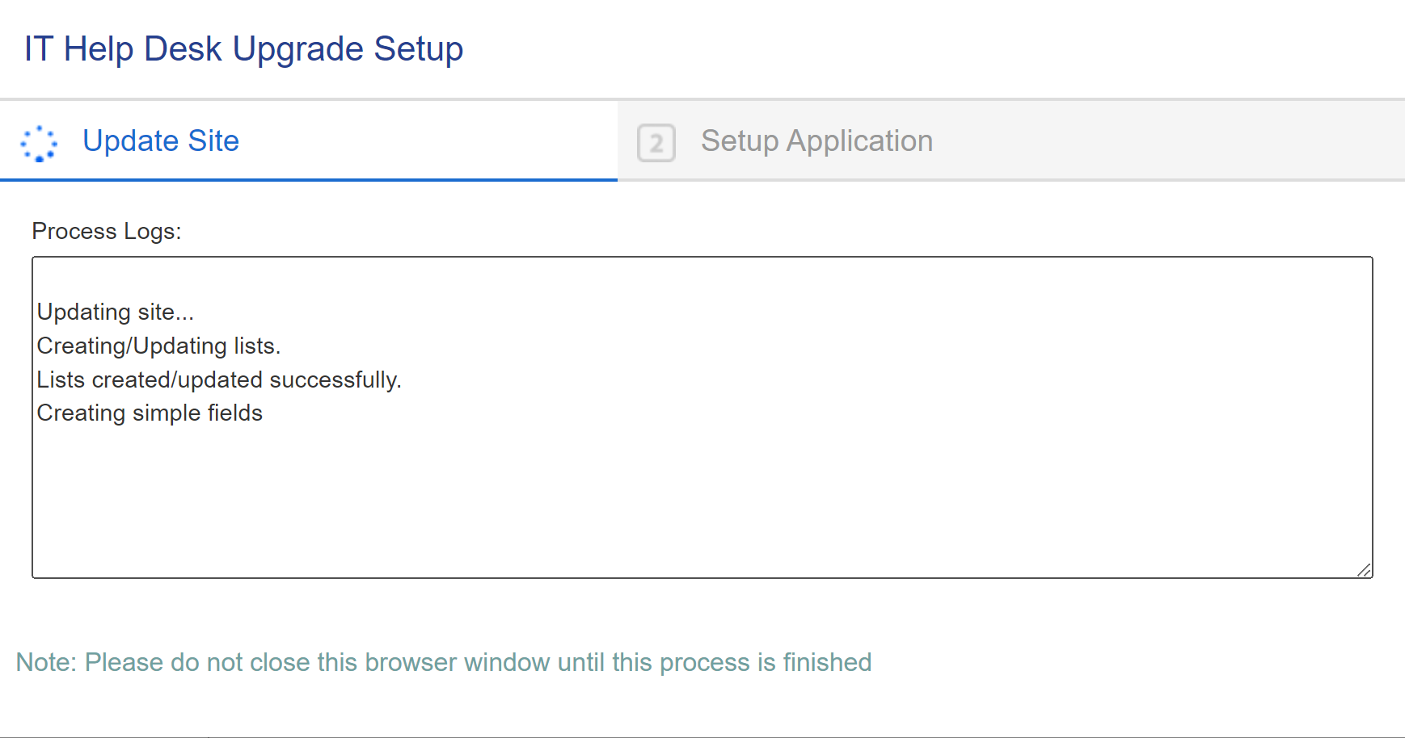

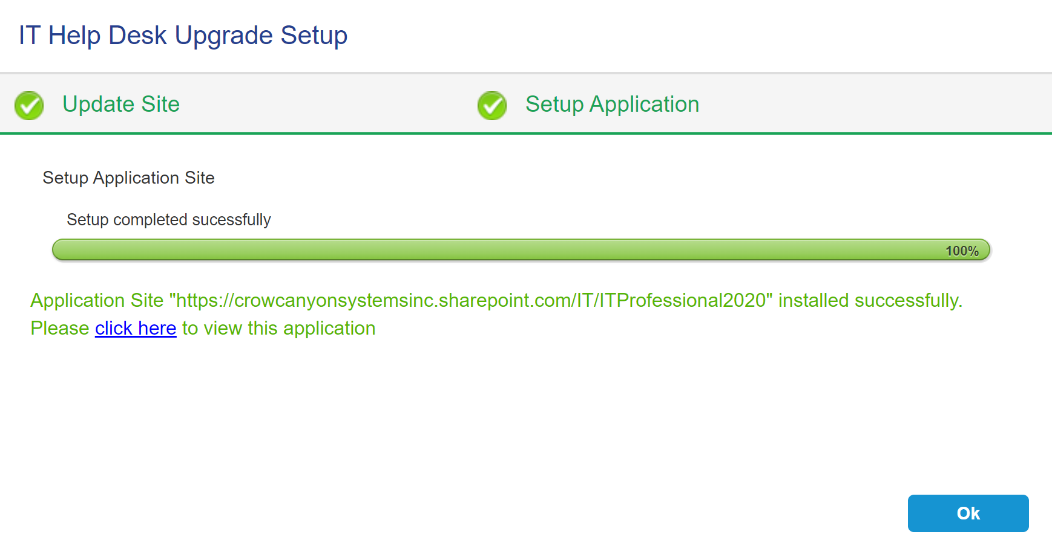

### You have successfully upgraded your IT Help Desk 2020 to NITRO Help Desk 2023. Now you can configure and use new features as per your requirements.

#### Service Level Agreements (SLAs)

Follow the below instructions to configure and use SLAs.

**Important Note**: Go-to “NITRO Workflows” in the upgraded site. If any of the below mentioned out of the box workflows have been modified, then do not proceed further to configure SLAs and contact [crowcanyonsupport@crowcanyon.com](mailto:crowcanyonsupport@crowcanyon.com) to use new SLA feature.

* 1. “Update Time to Assign” workflow on “Tickets” list.
  2. “Update First Response Time for Staff Incoming email” workflow on “Email Tickets” list.
  3. “Update First Response Time on Outgoing Email” workflow on “Email Tickets” list.
  4. “Update Ticket with time to resolve and close and first response” workflow on “Tickets Status Tracking” list.

#### Step 1: Enable new workflows created as a part of upgrade application.

Go-to “NITRO Workflows” and enable “Update Ticket with time to resolve and close” workflow on “Tickets Status Tracking” list as shown below:



#### Step 2: Disable existing workflows.

Go-to “NITRO Workflows” and disable below workflows.

* 1. Update Time to Assign
  2. Update First Response Time for Staff Incoming email.
  3. Update First Response Time on Outgoing Email
  4. Update Ticket with time to resolve and close and first response

Note: If any other workflows have been created for SLAs apart from above four workflows, then disable them as well.

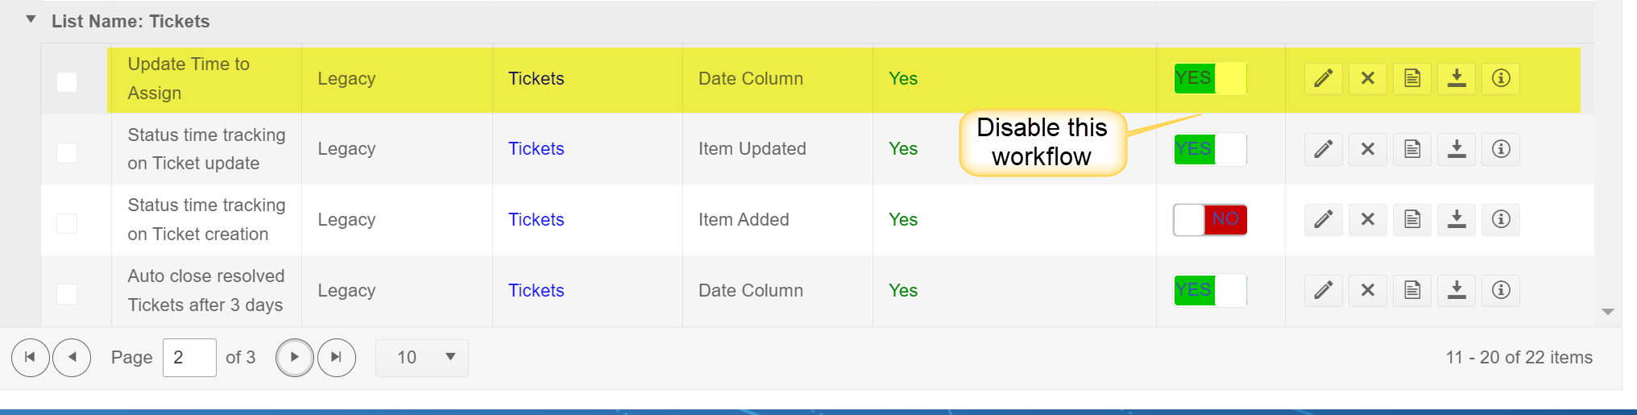

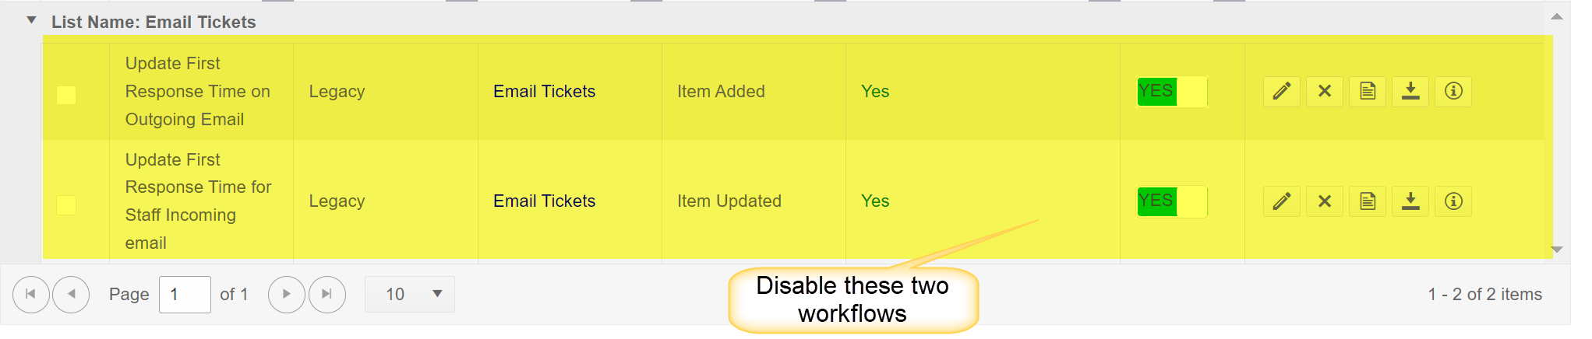



#### Step 3: Configure and test SLAs.

Out of the box, SLA comes with “Default Policy” in disabled state. You can either enable default policy and use it or configure your own custom policies. Please refer to [SLA.docx (sharepoint.com)](https://crowcanyonsoftware.sharepoint.com/:w:/r/sites/CrowCanyonIntranet/CS/_layouts/15/Doc.aspx?sourcedoc=%7B1C84E166-487A-4266-A4DC-4A9565FCAF96%7D&file=SLA.docx&action=default&mobileredirect=true) for more details on how to configure SLAs. Please test your newly configured SLA functionality.

***Note: If you are experiencing any issues in configuring SLA or its functionality, then revert the SLA changes as described below and do not proceed further. Please contact*** [***crowcanyonsupport@crowcanyon.com***](mailto:crowcanyonsupport@crowcanyon.com) ***for further assistance.***

1. ***Re-enable all workflows that were disabled in Step 2***
2. ***Disable SLA Policies that are enabled in Step 3***
3. ***Disable new workflow which was enabled as part of step 1***

#### Step 4: SLA Reports Dashboard

As part of upgrade application, “SLA Reports” dashboard page will be created in “Site Pages” library.

If you want, you can add “SLA Reports” page in quick launch section of your IT Help Desk. Please click [here](https://crowcanyonsoftware.sharepoint.com/:w:/s/CrowCanyonIntranet/CS/ET2bRZnWTABJmoDkxn3mJhMB8Ntio_KPSwUBvPzuc9ukJA?e=FVBBNg) for more details on how to add a page in quick launch.

#### Surveys

Follow the below instructions to configure and use Surveys.

#### Step 1: Enable “Status Time Tracking” feature in Product app by referring [this](https://crowcanyonsoftware.sharepoint.com/:w:/s/CrowCanyonIntranet/CS/EdQDlnyq-8RJr_h32h08dDYB2MB6YBcrFZUZN8aFdSZysg?e=tvVodn) article.

#### Step 2: Enable new workflows created as a part of upgrade application.

Go-to “NITRO Workflows” and enable below workflows as shown:

* “Notify requester with survey link on Ticket close” workflow on “Ticket Status Tracking” list.
* “Update survey feedback details in Ticket” workflow on “Survey” list.



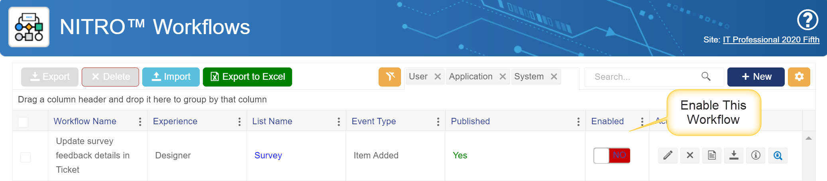

#### Step 3: Test and verify the Survey feature.

Verify that survey feature is working fine by closing a test ticket and verifying that the survey email went to the requester. Requester will be getting two notifications (one for ticket completion and one for survey) until we execute step 4 below.

Note: If you are experiencing any issues in configuring Surveys or its functionality, then revert the changes as described below and do not proceed further. Please contact [crowcanyonsupport@crowcanyon.com](mailto:crowcanyonsupport@crowcanyon.com) for further assistance.

1. Revert changes done as part of Step 1
2. Disable new workflow which was enabled as part of step 2

#### Step 4: Disable out of the box requester notification in “Notification on Ticket Completion” utility.

Go to Application Administration 🡪 Notifications 🡪 Click “Notification on Ticket Completion” utility and uncheck “Notify Requester”.

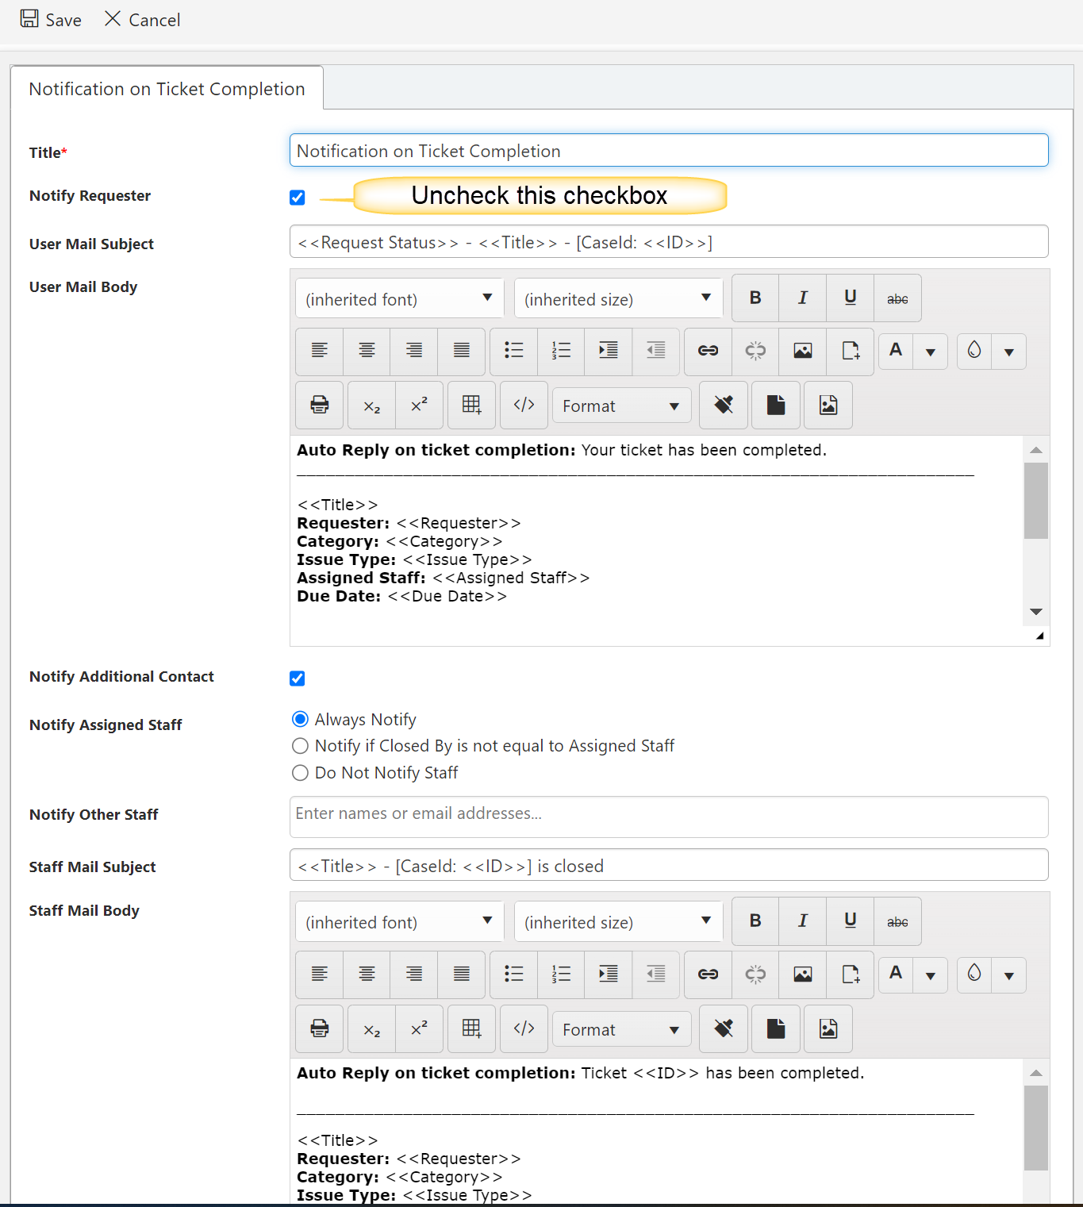

#### Step 5: Survey Reports Dashboard

As part of upgrade application, “Survey Reports” dashboard page will be created in “Site Pages” library. If you want, you can add “Survey Reports” page in quick launch section of your IT Help Desk. Please click [here](https://crowcanyonsoftware.sharepoint.com/:w:/s/CrowCanyonIntranet/CS/ET2bRZnWTABJmoDkxn3mJhMB8Ntio_KPSwUBvPzuc9ukJA?e=FVBBNg) for more details on how to add a page in quick launch.

#### Needs Attention

“Needs Attention?” column has been created in “Tickets” list as part of IT Helpdesk upgrade. You can create a new SharePoint list view to identify the tickets which needs attention or add ‘Needs Attention’ column to an existing view.

Refer [this](https://support.microsoft.com/en-us/office/create-change-or-delete-a-view-of-a-list-or-library-27ae65b8-bc5b-4949-b29b-4ee87144a9c9) article to create or modify a view.

#### Merge Ticket, Link to Problem and Link Tickets to Problem

Follow the below instructions to configure and use these features.

*Step 1: Download package from* [*here*](https://crowcanyon.info/NITRO/download/Tools_28April23/MD5_71c121c220bb0749dbe3ffbc36ca3c01/NITROHelpdesk_UpgradePackage.zip)*.*

The package contains below files for custom actions.

* Merge Ticket.xml
* Link to Problem.xml
* Link Tickets to Problem.xml

*Step 2: Import ‘Merge Ticket.xml’ and ‘Link to Problem.xml’ files in “Tickets” list custom actions*.

Please refer to [this](https://crowcanyonsoftware.sharepoint.com/:w:/s/CrowCanyonIntranet/CS/EY7SpHp9765DuQ8OHOKlBu0B39BFVv7Pfj2XveIaTOPWwg?e=epXot8) article to import custom actions.

*Step 3: Import ‘Link Tickets to Problem.xml’ file in “Problems” list custom actions.*

*Step 4: Hide ‘Merge Ticket’ and ‘Link to Problem’ custom actions in Portal ticket form.*

Go-to Site Contents -> Application Administration -> Advanced -> Configure Lists -> Configure Tickets -> NITRO Forms -> Edit PortalTicket form -> click Design Display PortalTicket Form -> In layouts sections -> hide custom actions.

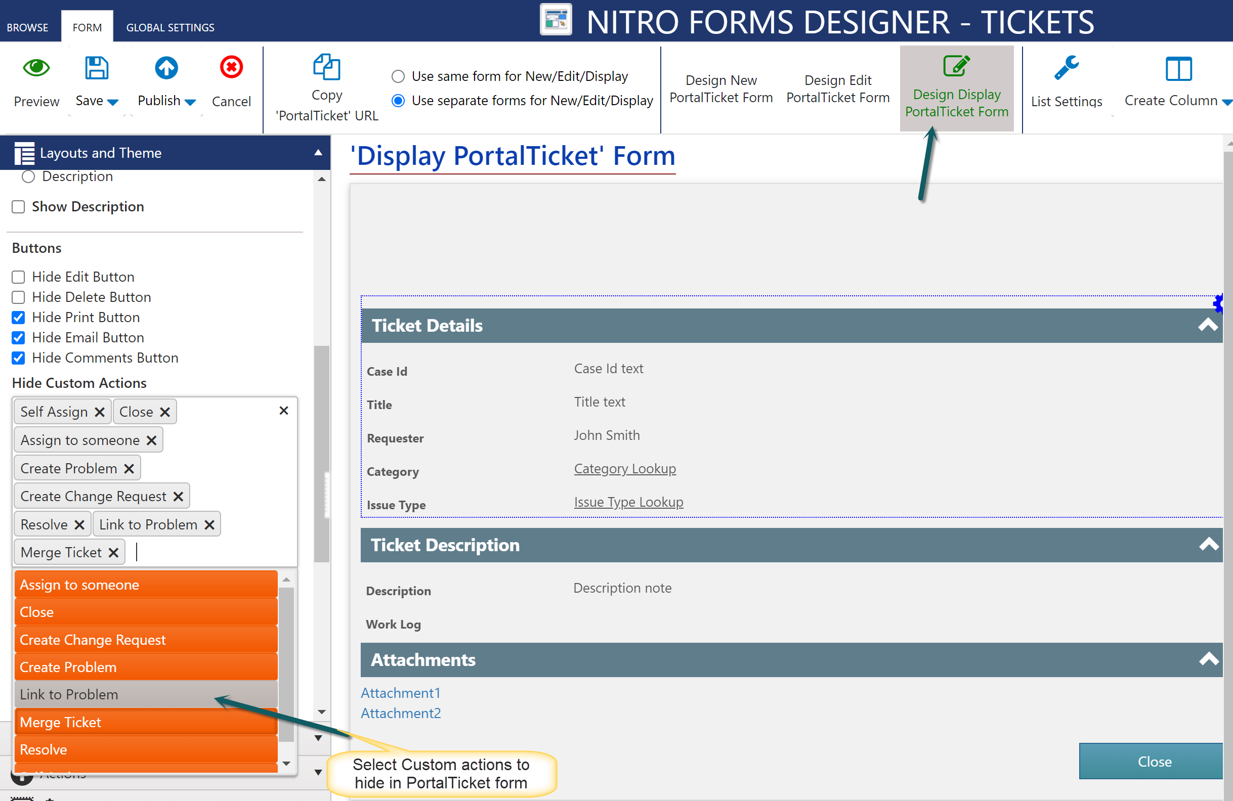

Publish the form again.